**NATURAL DISASTER INTENSITY ANALYSIS AND CLASSIFICATION USING ARTIFICIAL INTELLIGENCE**

**Team ID**: LTVIP2023TMID08241

Submitted by   
   
 M.Durga Mounika (20NM1A04A1)

N.Tejasree (20NM1A04B4)

K.Surya Prasanna (20NM1A0478)   
 B.Darshini (20NM1A0431)  
 

BACHELOR OF ENGINEERING  
 IN  
 Electronics and Communication Engineering



VIGNANS INSTITUTE OF ENGINEERING FOR WOMENS

## TABLE OF CONTENTS

1. **INTRODUCTION** 
   1. Project Overview
   2. Purpose
   3. Problem statement
   4. Proposed solution
2. **REQUIREMENT ANALYSIS** 
   1. Functional requirement
   2. Non-Functional requirements
3. **PROJECT DESIGN** 
   1. Data Flow Diagrams
   2. Solution & Technical Architecture
   3. User Stories
4. **PROJECT PLANNING & SCHEDULING** 
   1. Sprint Planning & Estimation
   2. Sprint Delivery Schedule 6.3 Reports from JIRA

5.I**MAGES FOR NATURAL DISASTERS**

**6.CODING & SOLUTIONING**

* 1. Feature 1
  2. Feature 2

**7.TESTING**

* 1. Test Cases
  2. User Acceptance Testing

**8.RESULTS**

* 1. Performance Metrics

**9.Advantages and Disadvantage**

**10.CONCLUSION**

**11.FUTURE SCOPE**

## 1.INTRODUCTION

### PROJECT OVERVIEW

Natural disasters are large-scale geological or meteorological events that have the potential to cause loss of life or property. A disaster is a result of a natural or man-made hazard impacting a vulnerable community India is one of the most disaster-prone countries in the world. A disaster is a serious disruption of a community or a society involving widespread human, material, economic or environmental losses and impacts ,which exceeds the ability of the affected community to cope using its own resources. The locational and geographical features render it vulnerable to a number of natural hazards such as drought ,fire ,landslides and avalanches. Disaster can be caused by naturally occurring events such as earthquake, cyclone ,flood, and wildfires. This will destroy the properties of human societies and even lead to permanent change in the ecosystem. Natural disasters are inevitable but the occurrence of this drastically effects the human-life. To tackle this problem ,this project proposes a AI based disaster management

### PURPOSE:

The purpose of natural disaster intensity analysis and classification using AI is to build a deep learning model that can classify and tell the intensity of a natural disaster based on images. This can help to overcome losses in ecosystems, human lives, and properties by providing timely and accurate information for disaster management and response. Basically, the Main objective of natural disaster management reduce the damage. However, there are several on Objectives that are integrated with it. Identifying the hazard and its cause. Reducing vulnerability and potential loses of hazard. Assessing, reviewing and controlling the risk. Reducing the damage, death, sufferings and destruction of any natural and human induced disaster Giving protection to victims. Increasing the strength among people to survive among disasters. Building up capacity in every sector like-individual, social, economic, environmental, national and international. Ensuring the availability of local emergency equipment and transportation. Promote the culture of disaster risk prevention and mitigation at all levels.

**PROBLEM STATEMENT :**

Disaster can be caused by natural occurring events such as earthquakes, cyclones , floods and wildfires. Many deep-learning techniques have been applied by various researches to detect natural disasters to overcome losses in ecosystem ,but detection of natural disasters still faces issues due to the complex and imbalanced structures of images. To tackle this problem we process a multi-layered deep convolutional neutral network. A civilian who is aware about natural disasters and takes the prediction methods to save nature. Due to natural disasters ,there are droughts ,economic crisis ,capital destruction etc. Natural disasters are increasing because of population growth , urbanization (a lot of people in small places),alteration of the natural environment(man-made islands).

**PROPOSED SOLUTION:**

The main purpose of this model is to detect and classify the type of disaster with a high accuracy rate. To prevent natural disasters in the future, said model can be used to predict future disasters and take some action against heavy loss of human ecological systems and property. We propose a multi-layered deep convolution neural network. The proposed model works in two blocks: Block-1 convolutional neural network (B-1 CNN), for detection and occurrence of disasters. block-2 convolutional neural network (B-1 CNN), for classification of natural disasters intensity type with different filters and parameters. Building collapse, ailments spread and sometimes natural disasters such as tsunamis can devastate nations. The proposed multi-layered deep convolutional neural network was simulated on the computer system with core i7, central processing**.**

## 2. REQUIREMENT ANALYSIS

### 2.1 FUNCTIONAL REQUIREMENTS

The following are the functional requirements of the proposed solution.

|  |  |  |
| --- | --- | --- |
| **FR** No. | **Functional Requirement**  **(Epic)** | **Sub Requirement (Story / Sub-Task)** |
| FR-1 | **LOGIN** | Login by giving a mobile number, Gmail or google account and their loca on. |
| FR-2 | **ALERT** | The alert message is given to all the users when the cyclone hits. |
| FR-3 | **MONITORING** | Continuous monitoring of cyclones and climate changes. |
| FR-4 | **REPORTS** | Keeping the records of the previous cyclone and refer news from meteorologist for live updates. |
| FR-5 | **END USERS** | The information is sent to the farmers using the database. |
| FR-6 | **END GOAL** | Inform farmers about the cyclone and its intensity. |

## 2 .2 NON-FUNCTIONAL REQUIREMENTS

The following are the non-functional requirements of the proposed solution:

|  |  |  |
| --- | --- | --- |
| **FR**  **No.** | **Non-Functional Requirement** | **Description** |
| NFR-  1 | **USABILITY** | While using this system, people turn on their current location on. They receive alert messages as no face on. The local officials can also inform and guide their nearby people and farmers by an alert message. |
| NFR-  2 | **SECURITY** | It does not share any personal information on to strangers. Their information on is to be encrypted and |
| NFR-  3 | **RELIABILITY** | As the details collected from satellite image and meteorologist and updated details in this system, so it is trustworthy. |
| NFR-  4 | **PERFORMANCE** | It runs in minimum storage space.  It will run efficiently when 1000 user’s login the same time. |

|  |  |  |
| --- | --- | --- |
| NFR-  5 | **AVAILABILITY** | It should be available in all Android phones and laptops. |
| NFR-  6 | **SCALABILITY** | As the product we created is user friendly and it will be very useful for farmers and agriculture. |

**3**. **PROJECT DESIGN**

### 3.1 DATA FLOW DIAGRAM

A data-flow diagram is a way of representing a flow of data through a process or a system. The DFD also provides information about the outputs and inputs of each entity and the process itself.

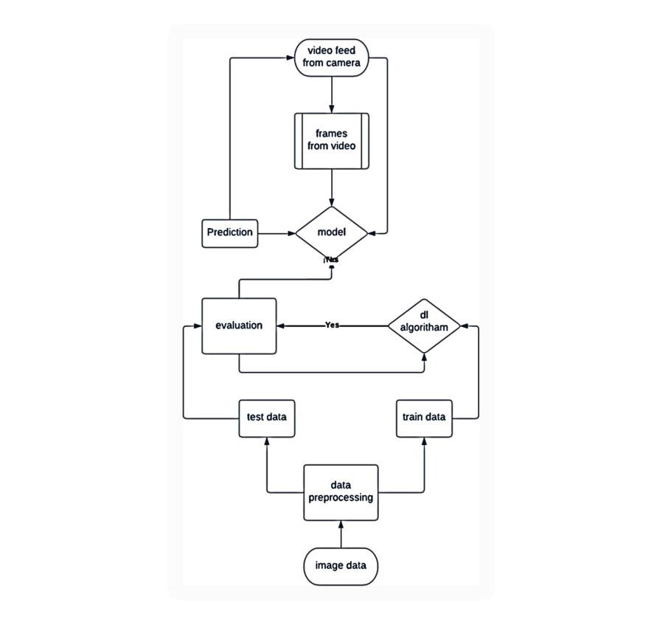

#### 3.2 USER STORIES

A user story is an informal, general explanation of a software feature written from the perspective of the end user or customer. The purpose of a user story is to articulate how a piece of work will deliver a particular value back to the customer**.**

|  |  |  |  |  |  |  |
| --- | --- | --- | --- | --- | --- | --- |
| **User**  **Type** | **Functional**  **Requirement**  **(Epic)** | **User**  **Story**  **Number** | **User Story / Task** | **Acceptance**  **criteria** | **Priority** | **Release** |
| Customer (Mobile user) | LOGIN | USN-1 | As a farmer, I can login by giving mobile number, Gmail or google account and their location. | I can prepare myself from cyclone and  storing enough food and essentials | High | Sprint- 1 |
|  | ALERT | USN-2 | As a farmer, I can receive the alert message when the cyclone hits. | I can know about current climatic conditions and upcoming weather conditions | High | Sprint- 2 |
|  | MONITORING | USN-3 | As a farmer, I can view the continuous monitoring of cyclone and  climatic changes. | I can know where the  cyclone hits and how much impacts it may creates | High | Sprint- 3 |
|  | REPORTS | USN-4 | As a farmer, I can keep the records of the previous cyclone and refer news from  meteorologist for  live updating. | I can receive the alert  messages when the disaster occurs | High | Sprint- 4 |
|  | END USERS  (farmers) | USN-5 | As a farmer, I can receive the information from the database. | I should ensure that any stored seeds or harvested crops are carefully protected from  wind and flooding | High | Sprint- 5 |

**3.3 SOLUTION AND TECHNICAL ARCHITECTURE**

## SOLUTION ARCHITECTURE

A solution architecture (SA) is an architectural description of a specific solution. SAs combine guidance from different enterprise architecture viewpoints (business, information and technical), as well as from the enterprise solution architecture (ESA).

## TECHNOLOGY STACK

A tech stack is the combination of technologies a company uses to build and run an application or project. Sometimes called a “solutions stack,” a tech stack typically consists of programming languages, frameworks, a database, front-end tools, back-end tools, and applications connected via APIs.

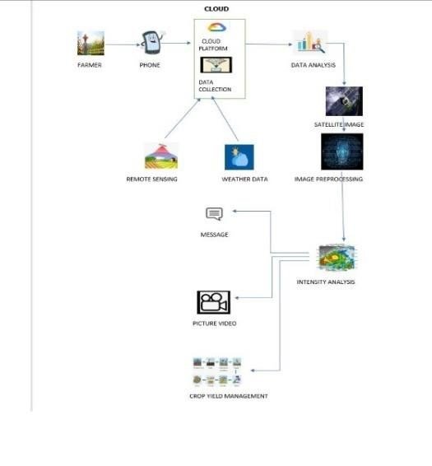

## 

## 4. PROJECT PLANNING AND SCHEDULING

### 4.1 SPRINT PLANNING AND ESTIMATION

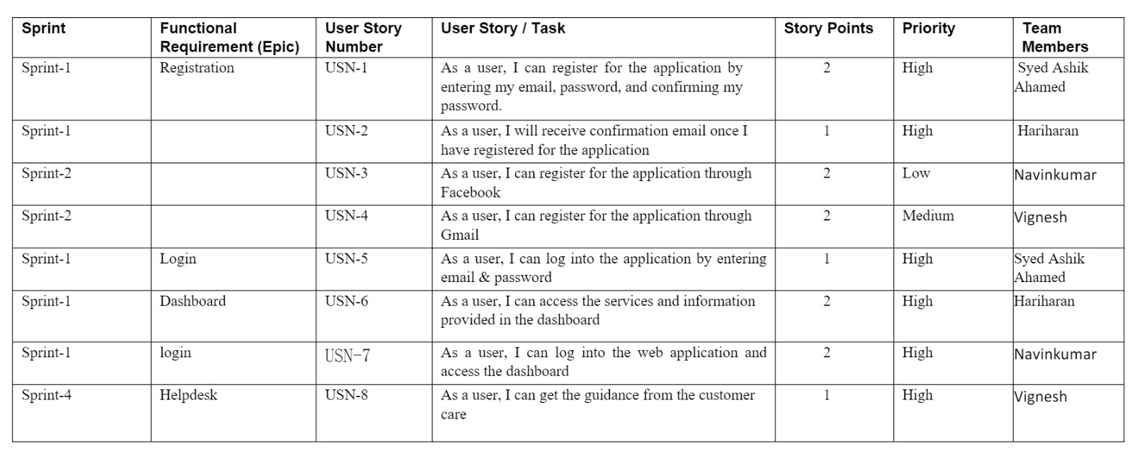

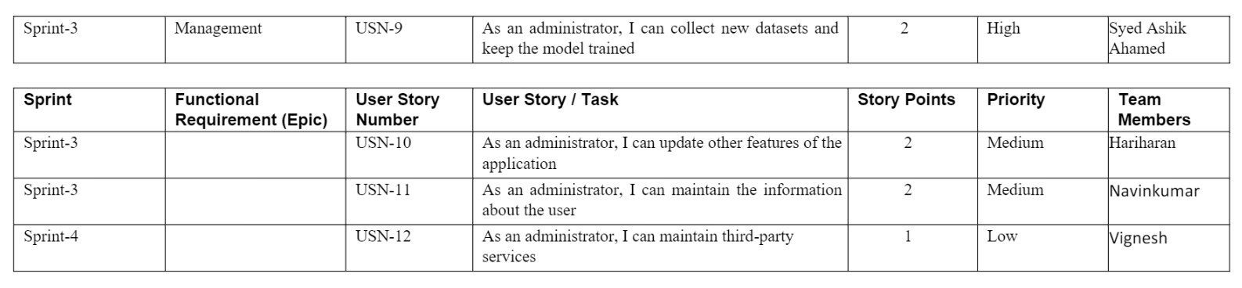

### 4.2 SPRINT DELIVERY SCHEDULE

|  |  |  |  |  |  |
| --- | --- | --- | --- | --- | --- |
| **Sprint** | **Total**  **Story**  **Points** | **Duration** | **Sprint**  **Start**  **Date** | **Sprint** End  **Date**  **(Planned)** | **Story**  **Points**  **Completed (as on**  **planned**  **End Date)** |
| Sprint 1 | **8** | **6 Days** | **26 Oct**  **2022** | **31 Oct**  **2022** | **8** |
| **Sprint 2** | **4** | **6 Days** | **01 Nov**  **2022** | **06 Nov**  **2022** | **4** |
| **Sprint 3** | **6** | **6 Days** | **07 Nov**  **2022** | **12 Nov**  **2022** | **6** |
| **Sprint 4** | **2** | **6 Days** | **13 Nov**  **2022** | **18 Nov**  **2022** | **2** |

### 4.3 REPORTS FROM JIRA

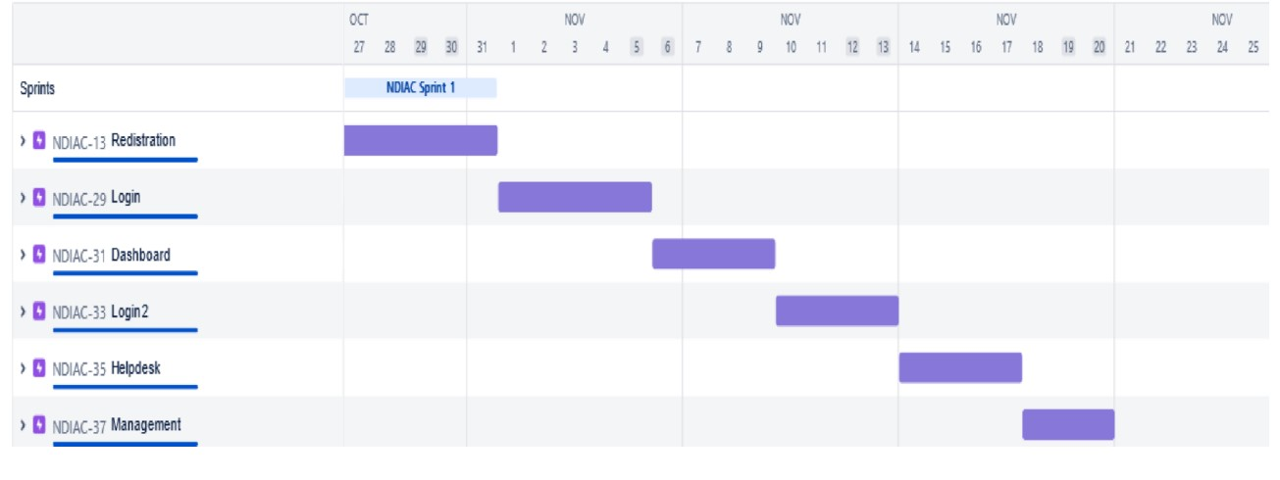

**5.** **IMAGES OF NATURAL DISASTERS**

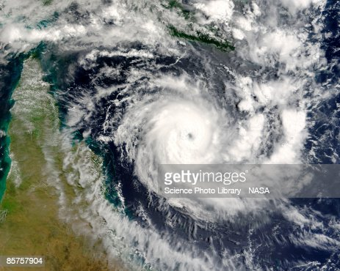

**CYCLONE**

* Tropical cyclones are one of the biggest threats to life and property even in the formative stages of their development. They include a number of different hazards that can individually cause significant impacts on life and property, such as storm surge, flooding, extreme winds, tornadoes and lighting. Combined, these hazards interact with one another and substantially increase the potential for loss of life and material damage.

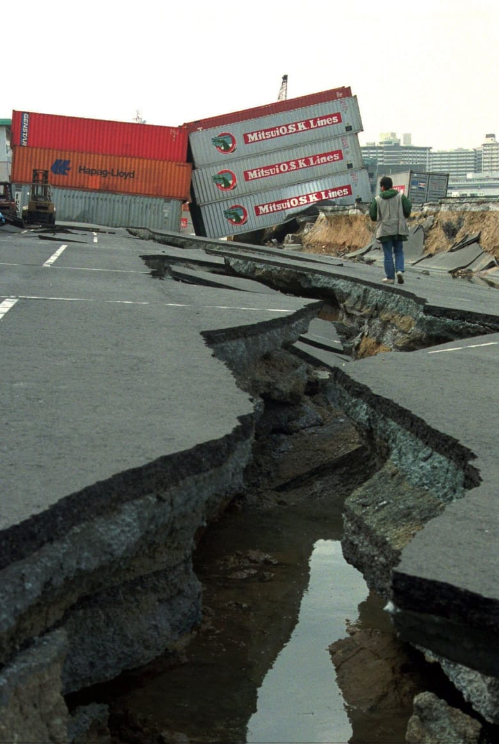

**EARTHQUAKE**

* Earthquakes occur most often along geologic faults, narrow zones where rock masses move in relation to one another. The major fault lines of the world are located at the fringes of the huge tectonic plates that make up Earth’s crust.

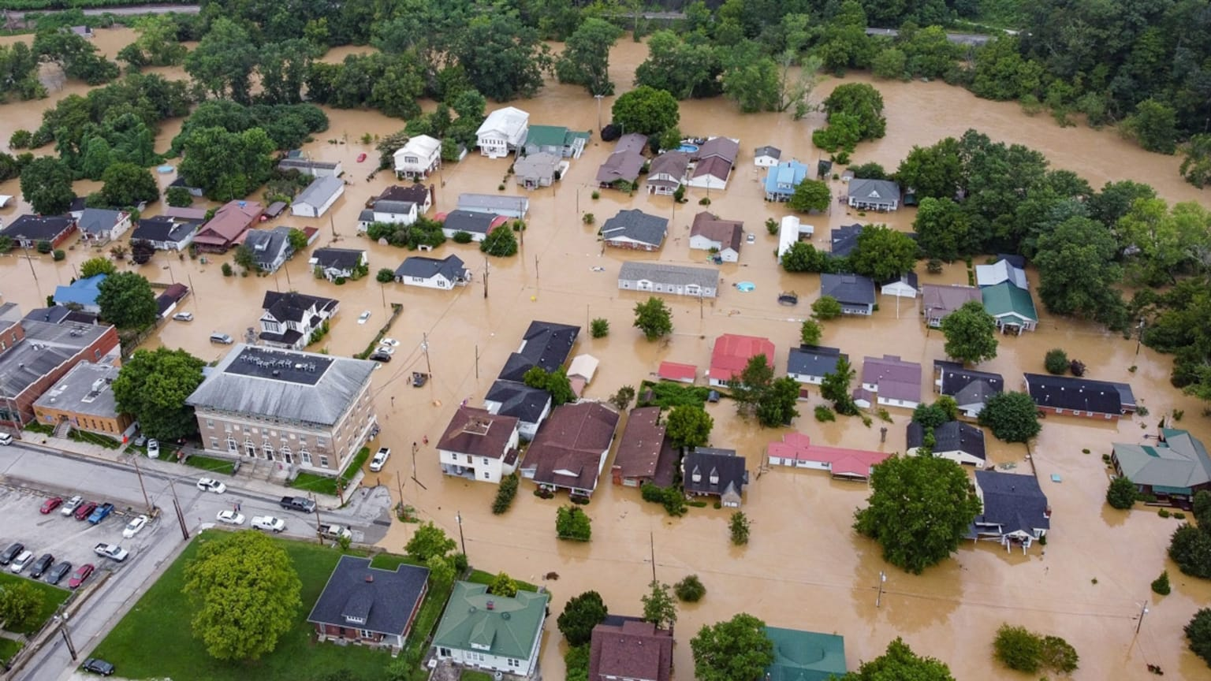

**FLOODS**

* Floods are a type of natural disaster that can cause heavy destruction to life and property. It is a condition when rainwater accumulates at a place, flooding populated areas. They can also lead to the loss of numerous lives. At times, it can be highly dangerous and can wipe off an entire village or city.

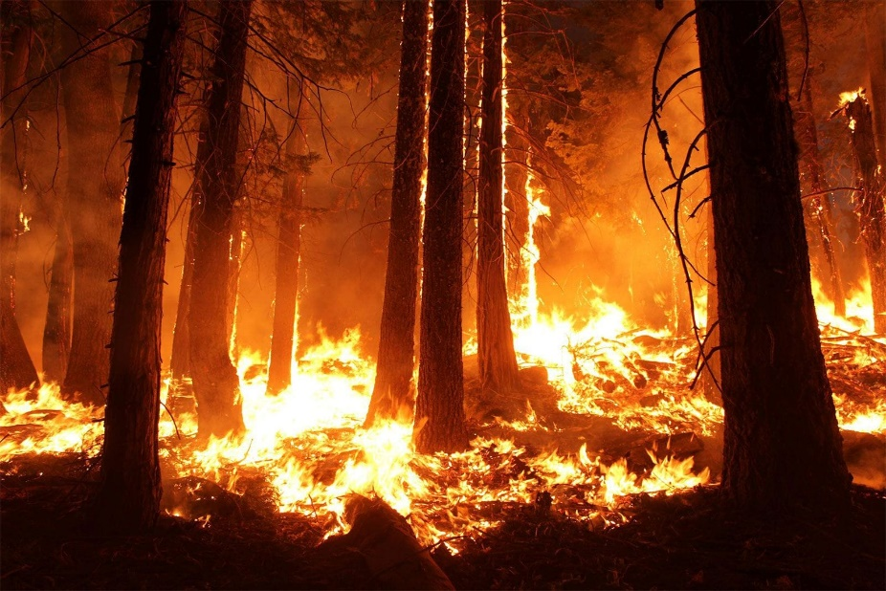

**WILDFIRE**

Wildfires occur when vegetated areas are set alight and are particularly common during hot and dry periods. They can occur in forests, grasslands, brush and deserts, and with sufficient wind can rapidly spread. Unchecked, such fires can cause devastation to forests and other areas of vegetation.

## 6. CODING AND SOLUTIONING

**5.1 FEATURE 1:**

**HTML**

**Home page:**

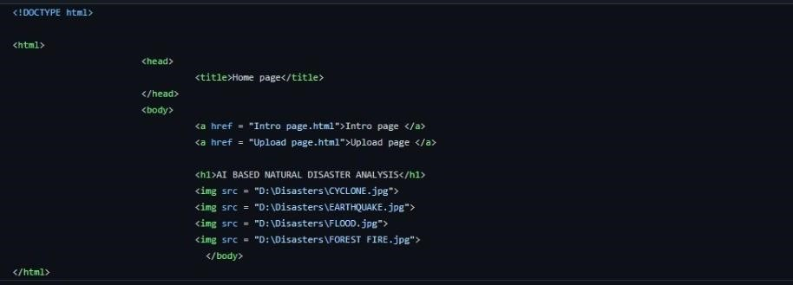

**Intro page:**

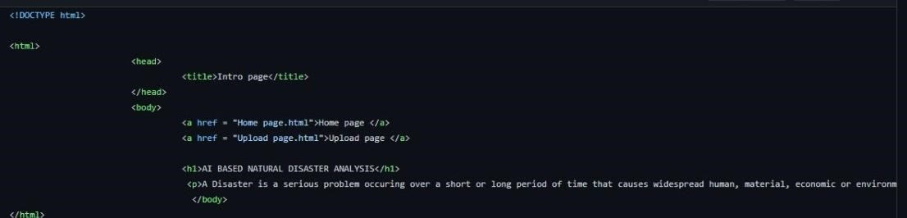

**Upload page:**

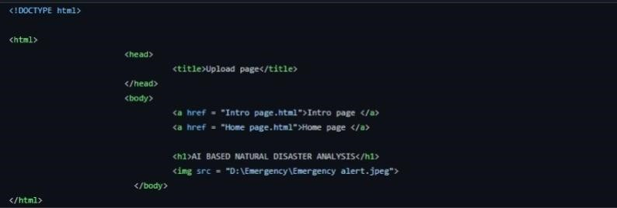

**5.2 FEATURE 2:**

**PYTHON**

from flask import Flask, render_template, request, redirect, url_for

import cv2

from tensorflow.keras.models import load_model

import numpy as np

from werkzeug.utils import secure_filename

app = Flask(__name__, template_folder="templates")

model = load_model('disaster.h5')

print("Loaded model from disk")

@app.route('/', methods=['GET'])

def index():

return render_template('home.html')

@app.route('/home', methods=['GET'])

def home():

return render_template('home.html')

@app.route('/intro', methods=['GET'])

def about():

return render_template('intro.html')

@app.route('/upload', methods=['GET', 'POST'])

def predict():

print("[INFO] starting video stream...")

vs = cv2.VideoCapture(0)

(W, H) = (None, None)

while True:

(grabbed, frame) = vs.read()

if not grabbed:

break

if W is None or H is None:

(H, W) = frame.shape[:2]

output = frame.copy()

frame = cv2.cvtColor(frame, cv2.COLOR_BGR2RGB)

frame = cv2.resize(frame, (64, 64))

x = np.expand_dims(frame, axis=0)

result = np.argmax(model.predict(x), axis=-1)

index = ['Cyclone', 'Earthquake', 'Flood', 'Wildfire']

result = str(index[result[0]])

cv2.putText(output, "activity: {}".format(result), (10, 120), cv2.FONT_HERSHEY_PLAIN,

1, (0, 255, 255), 1)

cv2.imshow("Output", output)

key = cv2.waitKey(1) & 0xFF

if key == ord("q"):

break

print("[INFO] cleaning up...")

vs.release()

cv2.destroyAllWindows()

return render_template("upload.html")

@app.route('/file', methods=['POST', 'GET'])

def video():

if request.method == 'POST':

uploaded_file = request.files['file1']

if uploaded_file.filename != '':

vid_name = str(uploaded_file.filename)

print(vid_name + "Uploaded_Succesfully")

uploaded_file.save(uploaded_file.filename)

vs = cv2.VideoCapture(vid_name)

if (vs.isOpened() == False):

print("Error opening video stream or file")

(W, H) = (None, None)

while True:

(grabbed, frame) = vs.read()

if not grabbed:

break

if W is None or H is None:

(H, W) = frame.shape[:2]

output = frame.copy()

frame = cv2.cvtColor(frame, cv2.COLOR_BGR2RGB)

frame = cv2.resize(frame, (64, 64))

x = np.expand_dims(frame, axis=0)

result = np.argmax(model.predict(x), axis=-1)

index = ['Cyclone', 'Earthquake', 'Flood', 'Wildfire']

result = str(index[result[0]])

cv2.putText(output, "activity: {}".format(

result), (10, 120), cv2.FONT_HERSHEY_PLAIN, 1, (0, 255, 255), 1)

cv2.imshow("Output", output)

key = cv2.waitKey(1) & 0xFF

if key == ord("q"):

break

print("[INFO] cleaning up...")

vs.release()

cv2.destroyAllWindows()

return render_template("file.html")

@app.route('/image', methods=['POST', 'GET'])

def image():

resulttext = ''

if request.method == 'POST':

uploaded_file = request.files['imgfile']

if uploaded_file.filename != '':

img_name = str(uploaded_file.filename)

print(img_name + "Uploaded Succesfully")

uploaded_file.save(uploaded_file.filename)

from tensorflow.keras.models import load_model

from keras.preprocessing import image

model = load_model("disaster.h5")

img = image.load_img(img_name, grayscale=False,

target_size=(64, 64))

x = image.img_to_array(img)

x = np.expand_dims(x, axis=0)

pred = model.predict_classes(x)

index = ['Cyclone', 'Earthquake', 'Flood', 'Wildfire']

result = index[pred[0]]

resulttext = result

return render_template('image.html', result_text=resulttext)

if __name__ == '__main__':

app.run(host='127.0.0.1', port=8000, debug=True)

## 7. TESTING

### 6.1 TEST CASES

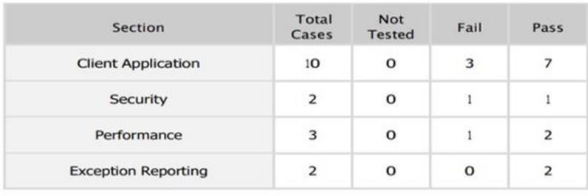

### 6.2 USER ACCEPTANCE TESTING

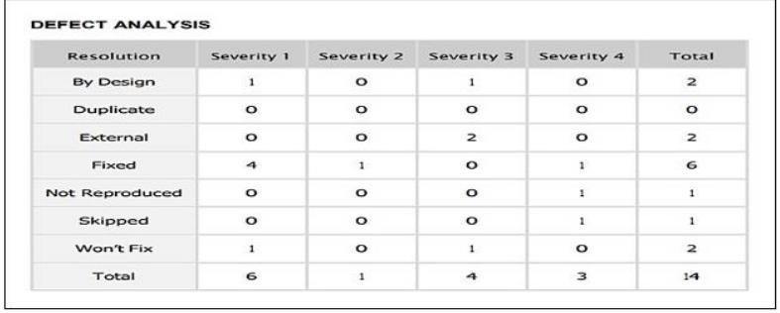

## 8.RESULTS

**7.1 PERFORMANCE METRICS**

### Locust Test Report

**During:** 11/20/2022, 12:20:34 PM - 11/20/2022, 12:29:21 PM

**Script**: locustfile.py

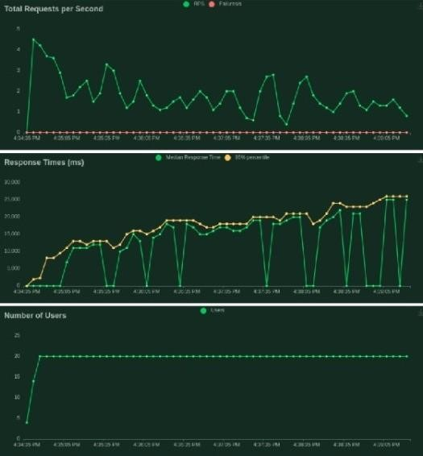

## 9.ADVANTAGES AND DISADVANTAGES:

## ADVANTAGES: -

## 

## 1.   Humans also need breaks and time offs to balance their work life and personal life. But AI can work endlessly without breaks.

## 2.   With the use of various AI based techniques, we can also anticipate today’s weather and

## the days ahead.

## 3.    Helpful in getting life back on track. 4.   Their Alert nature able to respond effectively and eﬃciently which defend the society from large scale damages.

## 

## DISADVANTAGES: -

## 

## 1.    It involves huge money to be equipped.

## 2.    Problems faced in life basic needs. 3.   One application of artiﬁcial intelligence is a robot, which is displacing occupations and increasing unemployment.

## 4.  Machines can perform only those tasks which they are designed or programmed to do, anything out of that they tend to crash or give irrelevant outputs which could be a major backdrop.

## 

## 10. CONCLUSION

Artificial intelligence has the potential to enhance the detection and classification of natural disasters, as well as the resilience and relief efforts

of affected communities. By using deep learning techniques, AI can analyse complex and imbalanced images of disasters and provide accurate and timely information. However, AI also faces challenges such as data quality, ethical issues, and human-AI collaboration. Therefore, it is essential to develop robust and reliable AI systems that can complement human expertise and judgment in disaster management.

AI can help predict the occurrence and impact of natural disasters by using historical data, satellite imagery, and weather models. This can enable early warning systems and preparedness plans for vulnerable areas. AI can also assist in the recovery and reconstruction of disaster-affected regions by providing insights into the needs and priorities of the survivors, as well as the best allocation of resources and funds.

AI can also support the learning and improvement of disaster management practices by analysing the lessons learned from past disasters and identifying the gaps and opportunities for future interventions.

## 11. FUTURE SCOPE

To develop more advanced and efficient deep learning models that can handle the complexity and diversity of natural disaster images, and provide accurate and reliable results.

To integrate multiple sources and types of data, such as text, audio, video, and sensor data, to enhance the analysis and classification of natural disasters and their impacts.

To explore the ethical and social implications of using AI for natural disaster management, such as the privacy, security, and accountability of the data and the algorithms, and the potential biases and risks of the AI outputs. To evaluate the performance and impact of AI for natural disaster management, and compare it with other methods and tools, such as human experts, traditional models, and manual processes. To foster the collaboration and communication among different stakeholders, such as researchers, practitioners, policymakers, and communities, to share the best practices and challenges of using AI for natural disaster management, and to co-create solutions that meet the needs and expectations of the users.

To promote the awareness and education of the public and the decision-makers on the benefits and limitations of AI for natural disaster

management, and to encourage the participation and feedback of the affected people and groups.